# PE11 – Defining Classes

1. Define the following terms.

inheritance: enable a class to reuse and extend the behaviors of other classes

parent/base class: parent: the class whose behaviors are reused and extended by its child class

base: the class is not complete, needed to be derived

child/derived class: child: the class that reuse and extend the behavior of its parent class

derived: implement class that is not complete

1. What is wrong with the following code?

public sealed class MyClass

{

// class members

}

public class myDerivedClass : MyClass

{

// class members

}

You cannot inherit from a sealed class

1. How would you define a non-creatable class?

static class NonCreatable{}

1. Why are non-creatable classes still useful? How do we make use of their capabilities? Give an example of a non-creatable class that we have used.

They are useful when all properties are not about objects, so we don’t need to create instances for these classes. It saves memory space, and it is easy to read. An example is Console.

1. Write code in a class library project (.NET .DLL) called Vehicles that implements the Vehicle family of objects as outlined below (_424DoubleBogey as the class identifier). There are nine objects and two interfaces (IPassengerCarrier and IHeavyLoadCarrier) that require implementation. The virtual method should be an empty function:

public virtual void LoadPassenger() { }

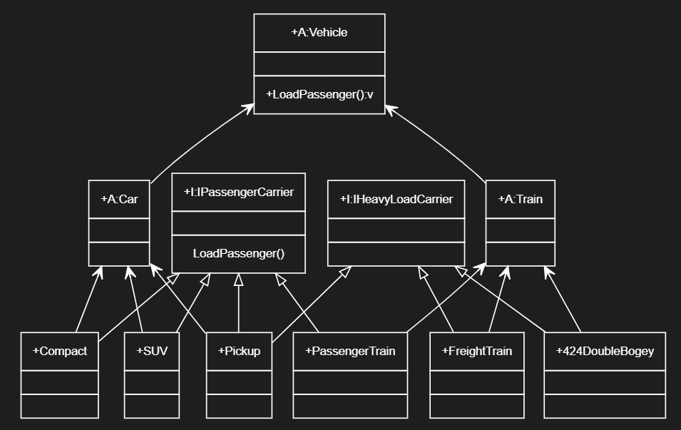

GitHub URL:

1. Create a console application project, Traffic, which references Vehicles.dll (created in Q5 above). Include a function called AddPassenger() that accepts any object with the IPassengerCarrier interface. Within the AddPassenger() function, call the LoadPassenger() method using a reference to the interface. Also add a line to call the ToString() method inherited from System.Object  (ie. if vehicleObject is passed to the function, call Console.WriteLine(vehicleObject.ToString()). Also try passing an object that did not inherit the IPassengerCarrier interface and see what happens.

GitHub URL:

https://github.com/whisperers26/IGME206---Homework.git

## Submission

Upload this completed document and GutHub URL's for #5 and #6 to the corresponding MyCourses dropbox.